**Supplier and Inventory Performance Analysis Report**

# Business Problem

In the competitive landscape of retail and wholesale, profitability hinges on strategic sales management, efficient inventory control, and strong vendor relationships. Companies often face challenges such as unbalanced supplier dependency, poor stock turnover, suboptimal pricing strategies, and inconsistent vendor performance. These issues can lead to capital lock-up, lost sales opportunities, and diminishing profit margins.

This analysis aims to provide actionable insights to support data-driven decision-making in the following areas:

* Pinpoint brands with high margins but poor sales performance that may benefit from promotional campaigns or revised pricing strategies.
* Identify the top-performing vendors contributing most significantly to sales revenue and gross profit.
* Analyze the cost-effectiveness of bulk purchasing and its impact on per-unit costs and margins.
* Evaluate inventory turnover across vendors to highlight inefficiencies and capital-intensive slow-moving stock.
* Compare profitability patterns between high-volume and low-volume vendors to identify pricing or operational gaps.

By addressing these key areas, the business can enhance operational efficiency, reduce risk, and strategically improve bottom-line performance.

# 1. Brands for Promotional or Pricing Adjustments

**Situation**

Certain brands show high profit margins but low total sales, indicating potential inefficiencies in pricing or market engagement.

**Task**

Identify brands that could benefit from promotional efforts or pricing adjustments to enhance their sales volume.

**Action**

Analyzed brand-wise data for total sales volume and profit margin. Filtered for brands with above-average margins but low sales.

**Result**

* **198 brands** were found to have high profit margins but low sales.
* These brands are ideal candidates for **targeted promotions**, **bundled offers**, or **price repositioning** to increase volume while maintaining profitability.

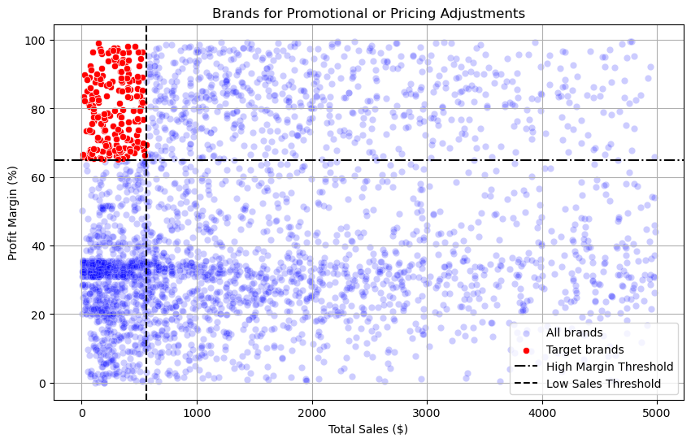

# 2. Top Vendors by Sales & Gross Profit Contribution

**Situation**

Vendor performance is skewed, with a small group contributing most of the revenue and profit.

**Task**

Evaluate the distribution of sales and purchases across vendors to assess dependency and identify key contributors.

**Action**

Grouped sales and gross profit by vendor. Calculated cumulative percentages to identify concentration.

**Result**

* The **top 10 vendors** account for **65.7% of total purchases**, highlighting potential **supply chain dependency**.
* Remaining vendors contribute only 34.3%, suggesting an opportunity to **diversify the supplier base**.

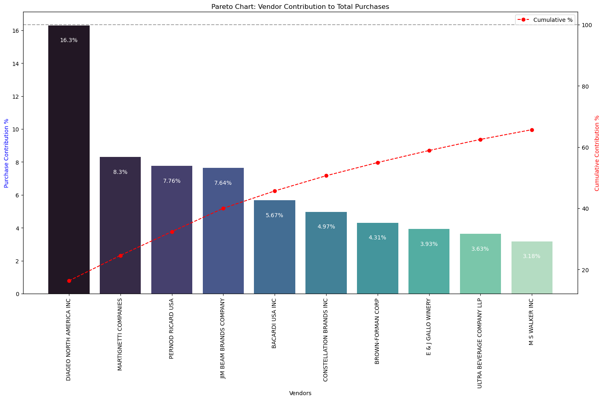

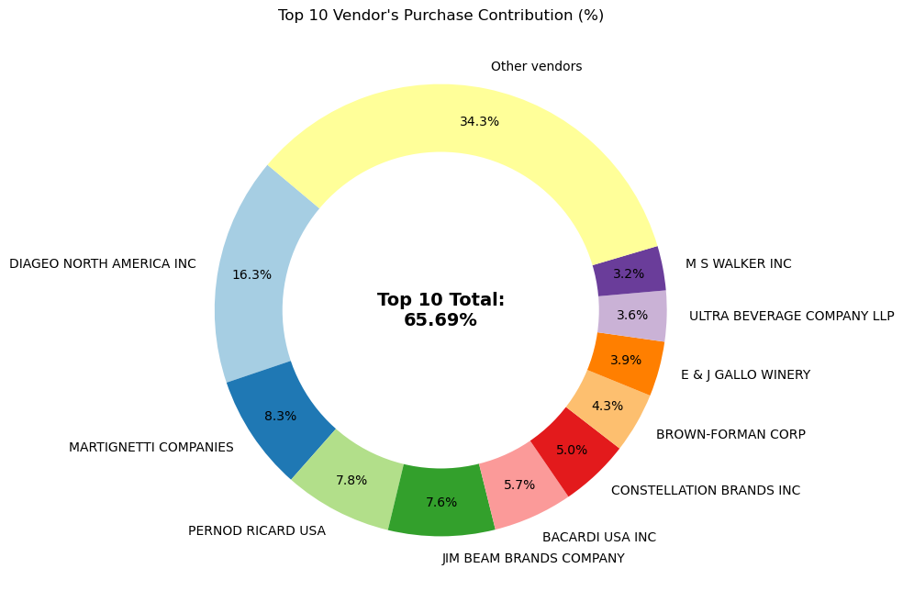

# 3. Impact of Bulk Purchasing on Unit Cost

**Situation**

Bulk purchasing is believed to reduce per-unit cost, potentially enhancing gross margins.

**Task**

Quantify how large purchase volumes affect the average unit cost across vendors.

**Action**

Segmented vendors by purchase quantity. Compared average unit costs between high and low volume segments.

**Result**

* Vendors with **larger purchase volumes** had an average unit cost of **$10.78**, which is **72% lower** than smaller-volume vendors.
* Bulk buying yields clear **cost advantages**, supporting **scale-based procurement strategies**.

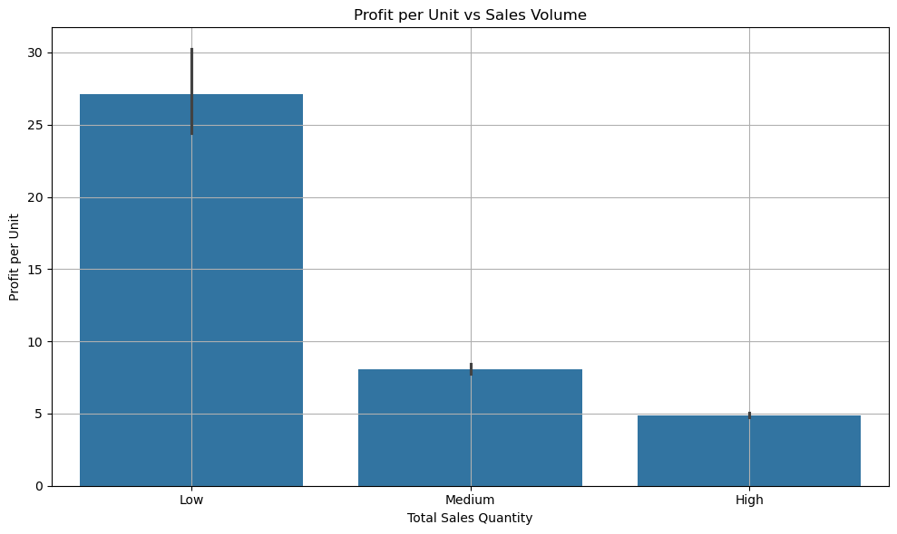

# 4. Inventory Turnover Analysis

**Situation**

Inventory holding costs rise when products remain unsold for extended periods.

**Task**

Determine which vendors or products are contributing to slow inventory turnover.

**Action**

Calculated stock turnover ratios per vendor and product. Flagged vendors with high unsold inventory value.

**Result**

* Unsold inventory across vendors totals **$2.71 million**, tying up capital and storage space.
* Vendors with **turnover < 1** show **inefficient inventory cycles**, prompting a need for **stock optimization**.

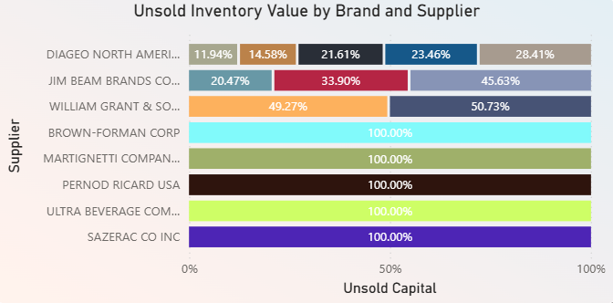

# 5. Profitability Comparison: High vs. Low-Performing Vendors

**Situation**

Some vendors achieve high sales volume but operate on thin margins, while others have high margins but low sales.

**Task**

Compare profit margins between the top-selling and low-selling vendor groups.

**Action**

Grouped vendors into top 10 (by sales) and bottom 10. Calculated average profit margins and performed hypothesis testing.

**Result**

* **Top Vendors' Mean Profit Margin**: **31.17%**
* **Low Vendors' Mean Profit Margin**: **41.55%**
* A statistical test confirms **significant difference** between the two, indicating **divergent pricing or cost structures**.

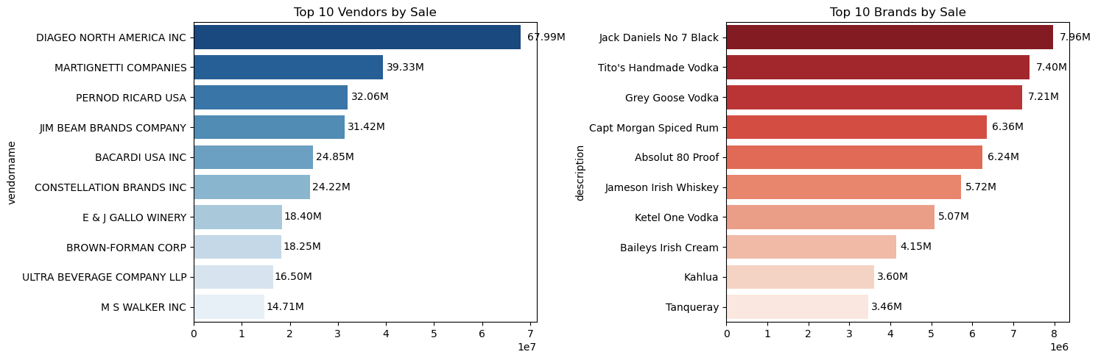

# 6. Statistical Validation of Margin Differences

**Situation**

Anecdotal evidence suggests high-margin vendors may be less efficient in volume sales.

**Task**

Test whether the difference in profit margins between high- and low-performing vendors is statistically significant.

**Action**

Performed **independent two-sample t-test** on vendor group margins.

**Result**

* **Null Hypothesis Rejected**: The two vendor groups operate under significantly different profitability models.
* Suggests that **low-performing vendors** may benefit from **marketing and distribution improvements**, while **top vendors** may optimize margins through **cost control or bundling**.

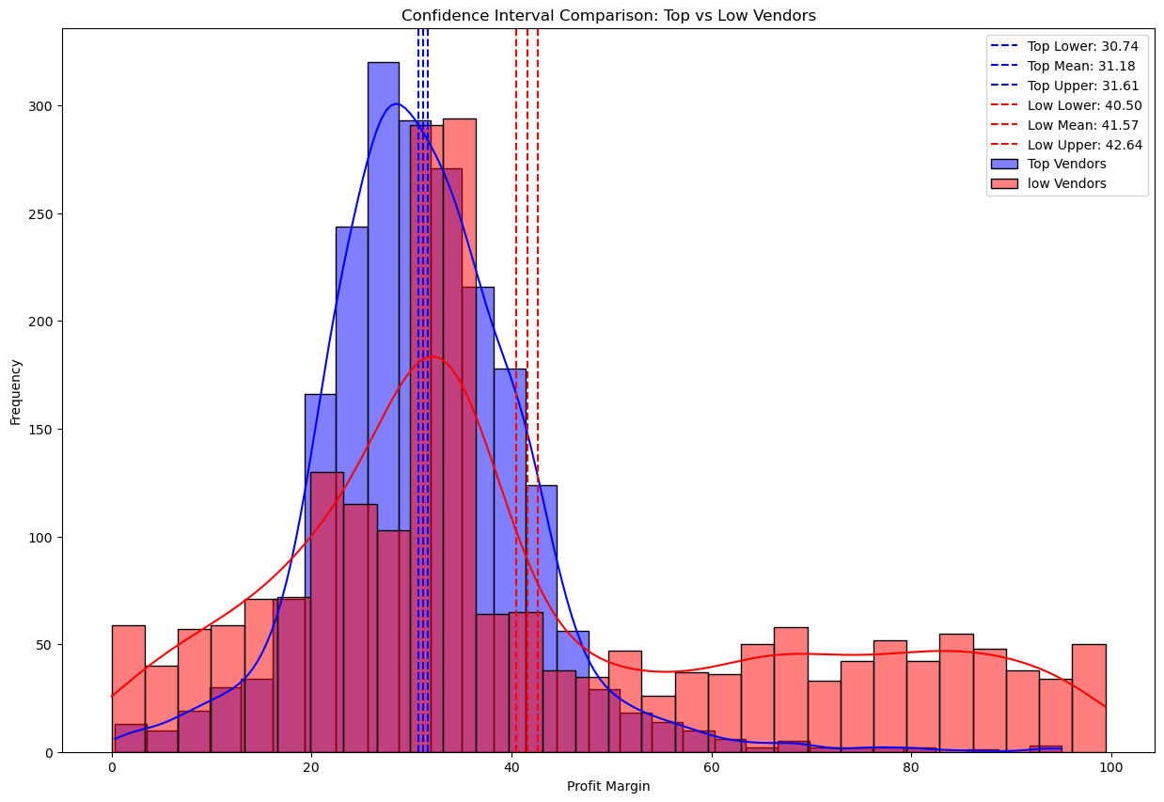

# Final Recommendations

1. **Reposition low-sales, high-margin brands** via strategic promotions or pricing adjustments.
2. **Diversify vendor partnerships** to reduce operational risk and dependency.
3. **Capitalize on bulk purchasing benefits** to lower per-unit costs.
4. **Reduce unsold inventory** via dynamic reorder thresholds, clearance sales, or automated forecasting.
5. **Support low-performing vendors** with better marketing tools, pricing analytics, and distribution efficiency.
6. **Enable continuous performance monitoring** through dashboards tracking inventory turnover, sales, and profit margins.